**Hospital Management System**

**Group Members**

* **Saad Iqbal L16-4046**
* **Kanwar Ahmad L16-4175**
* **Abdullah Naeem L16-4060**
* **Abeeq Jafar L16-4253**
* **Ahmad Bajwa L16-4033**

**Introduction:**

We are going to implement Hospital Management system for our OOAD Project. The **purpose** of this project is to provide and efficient and reliable management system to the hospital that would be beneficial to them avoiding any ambiguity in system.

**Users**

In our system we will have:-

* Admin
* Patients
* Doctors
* Nurses
* Staff
* Receptionist
* Accountant

**Characteristics of Users:**

* Admin will be able to manage account of user, data update, records
* Patients will be able to see their reports, booking appointment
* Doctor will be able to see list of patients, set and see appointment
* Nurse can assist doctor, medicate, check record of patient
* Pharmacy staff can update medicine record, handle prescription, manage inventory
* Regular staff don’t have profile
* Technical staff can be assigned certain tasks to manage networks, technical work, and do works related to electricity and machines
* Receptionist can set appointments for doctors, patients and check timings for doctors
* Accountant can handle accounts and billing.

**Use Cases:**

**Ahmad:**

* Log in and log out from system
* Delete Account
* Change Credentials

**Abeeq:**

* Generate test report
* Generate medicine reports
* Add Patient

**Abdullah:**

* Schedule Doctor Appointment
* Admit a patient
* File medial report

**Saad:**

* Generate test results
* Manage pharmacy inventory
* Manage hospital inventory

**Zaman:**

* Collect payment
* Prescribe treatment
* View medical history

**4. Use Cases Description:**

**Saad:**

**Use case name:** Generate test results

**Use case id:** 10

**Actors:** Nurse

**Description:** By clicking on generate test result, a form will be generated which will gather information of patient and test from the database.

**Pre-conditions:** Nurse must be logged in to access the database.

**Post-conditions:** A form will be available having information of the respective test and its result, which can be used for download or print purposes.

**Use case name:** Manage Pharmacy Inventory

**Use case id:** 11

**Actors:** Pharmacy staff

**Description:** A pharmacy staff member can update inventory as add, remove a particular thing. I.e. medicine, surgical instruments for sale.

**Pre-conditions:** Pharmacy staff member must be logged in to access the database of pharmacy.

**Post-conditions:** A Popup will be generated after pressing update button which will tell you all the changes in the inventory and after pressing close it will be saved in the database of pharmacy.

**Use case name:** Manage Hospital Inventory

**Use case id:** 12

**Actors:** Admin

**Description:** Only Admin can update inventory as add, remove a particular thing. I.e. medicine, surgical instrument or print out the current inventory for future purposes.

**Pre-conditions:** Admin must be logged in to access the database of hospital.

**Post-conditions:** A Popup will be generated after pressing update button which will tell you all the changes in the inventory and after pressing close it will be saved in the database of pharmacy.

**Use Case Diagram:**

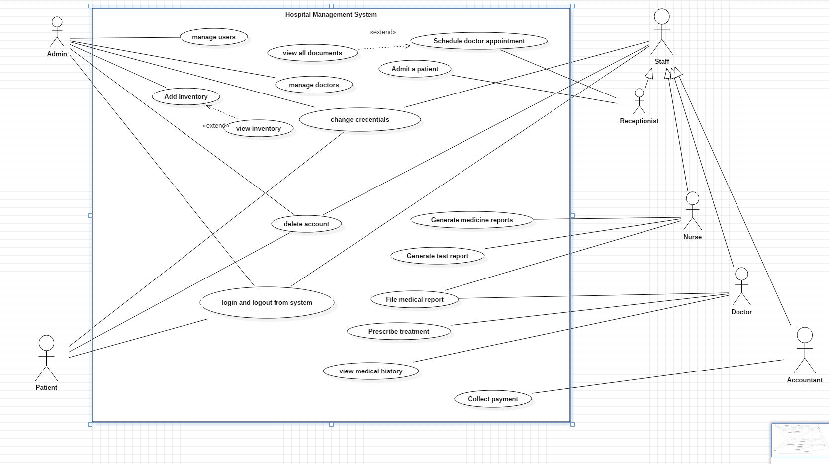

**5. Activity Diagrams of use cases:**

**Use Case Number: 10**

**Generate Test Result:**

**Sequence Diagram:**

**Use Case Number: 11**

**Manage Pharmacy Inventory:**

**Sequence Diagram:**

**Use Case Number: 12**

**Manage Hospital Inventory:**

**Sequence Diagram:**

**Use Case Number: 6**

**Add Patient**

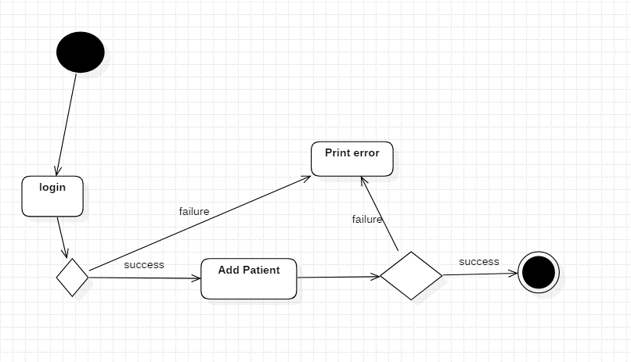

**Use Case Number: 5**

**Generate Medical Report**

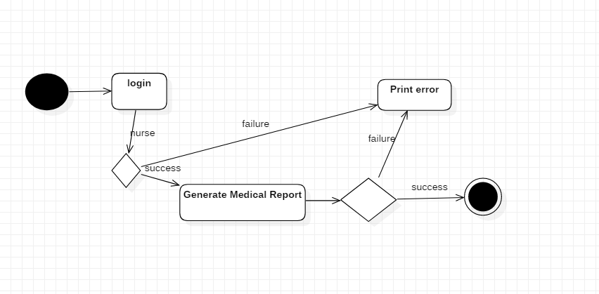

**Use Case Number: 4**

**Generate Test Report**

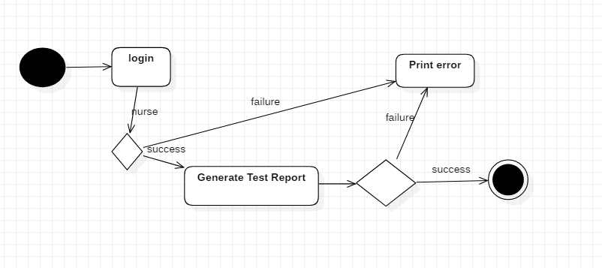

**Sequence Diagram**

**Add Patient**

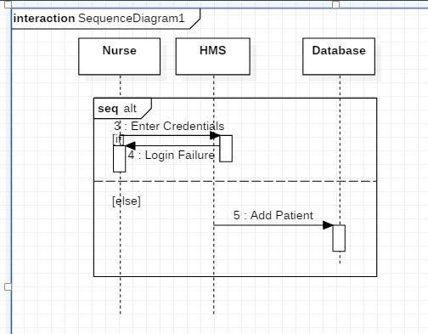

**Generate Medical Report**

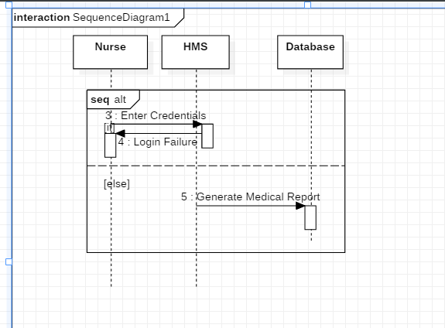

**Generate Test Report**

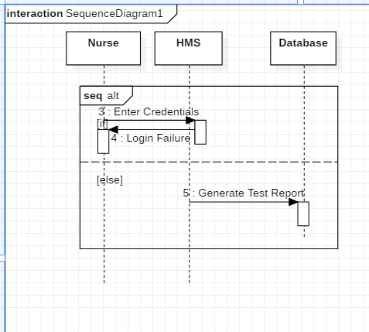

**Use Case Number: 7**

**Schedule a doctor’s appointment**

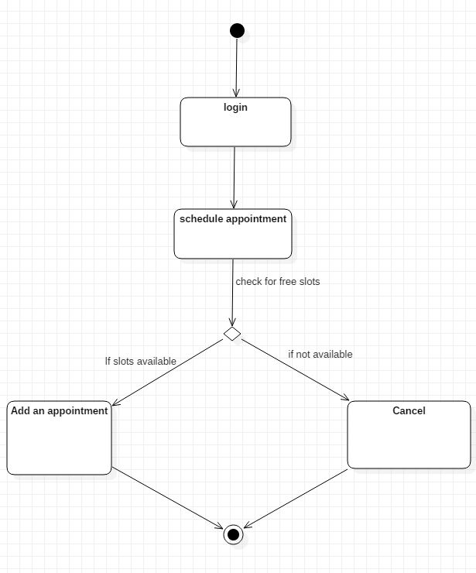

**Use Case Number: 8**

**Admit a patient**

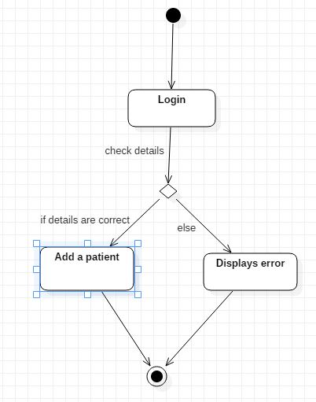

**Use Case Number: 9**

**File medical report**

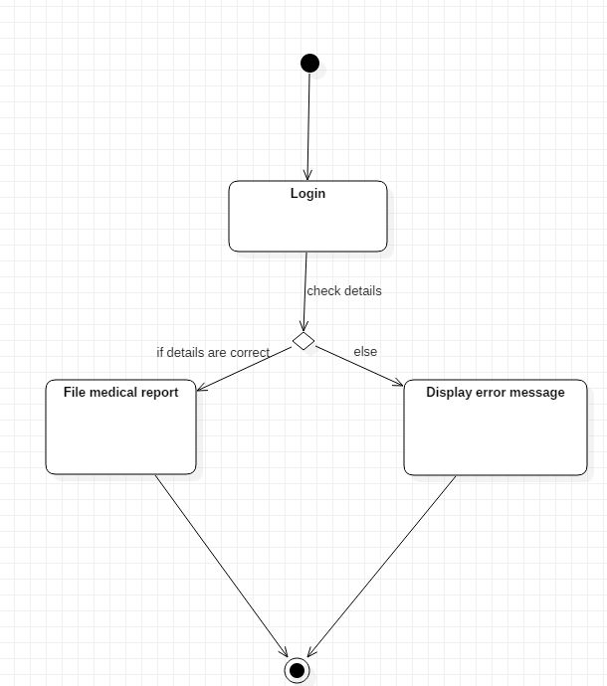

**Sequence Diagram**

**Schedule a doctor’s appointment**

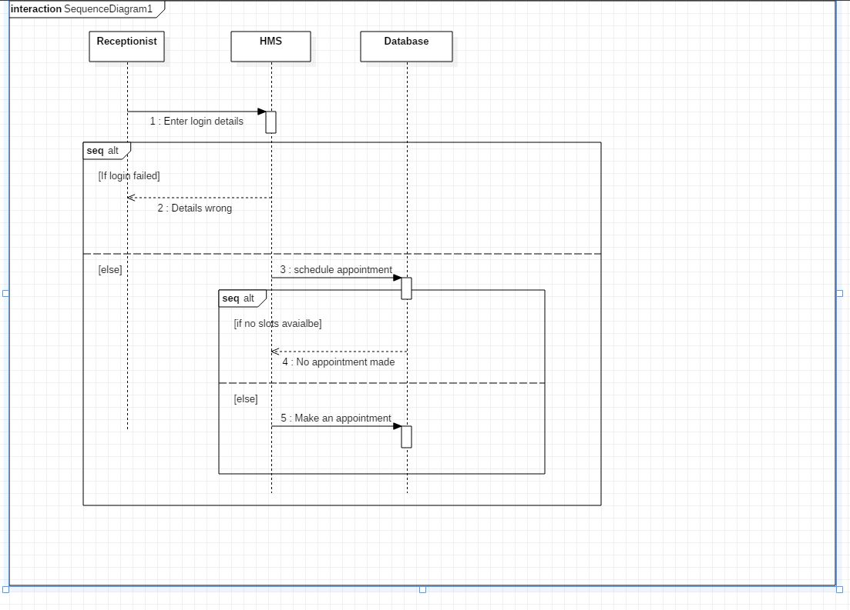

**File medical report**

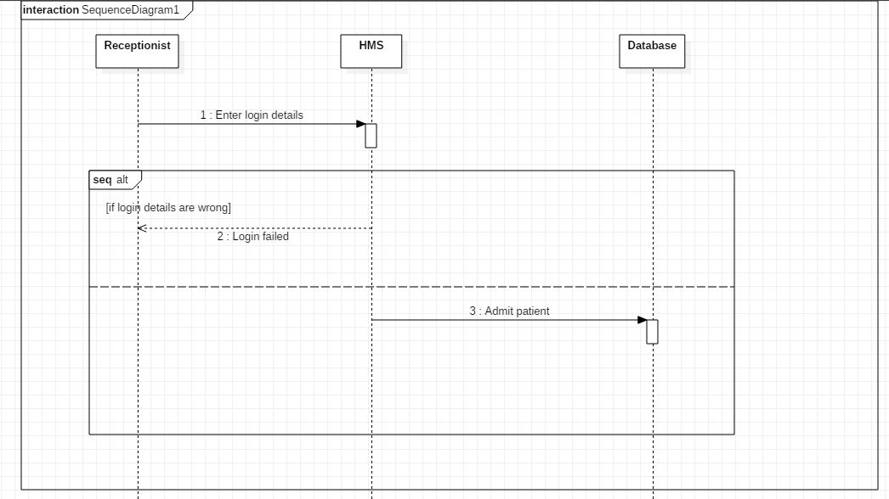

**Admit a patient**

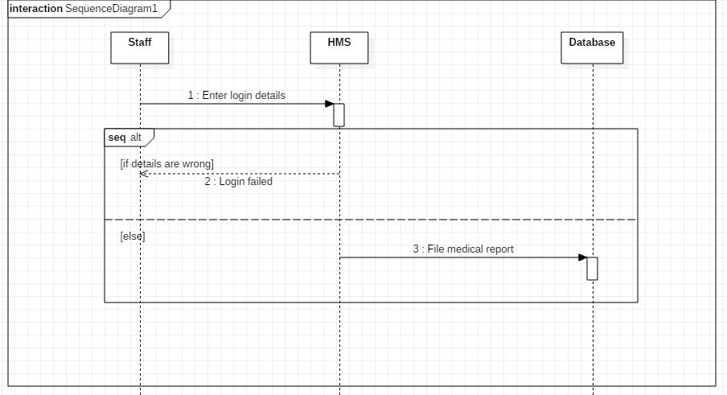

**Use Case Number: 1**

**Log in and out**

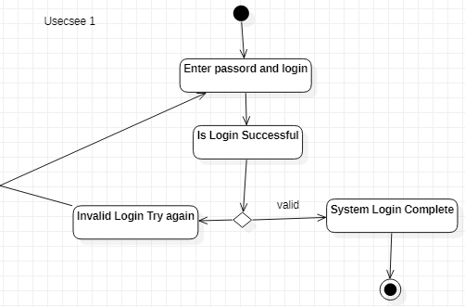

**Use Case Number: 3**

**Change credentials**

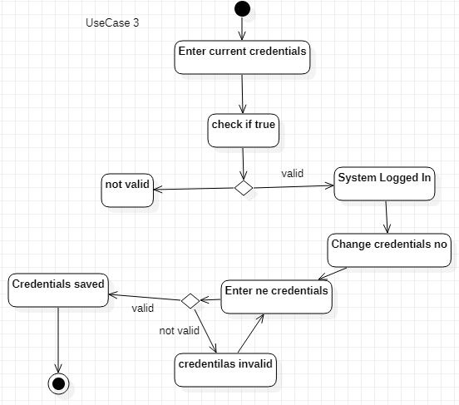

**Sequence Diagram**

**Log in and out**

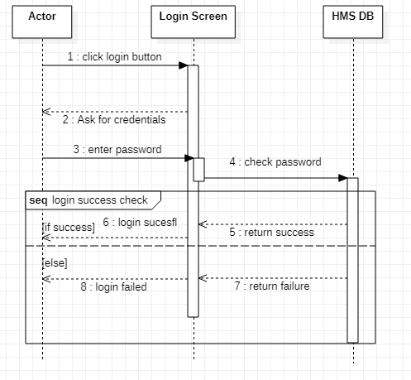

**Change credentials**

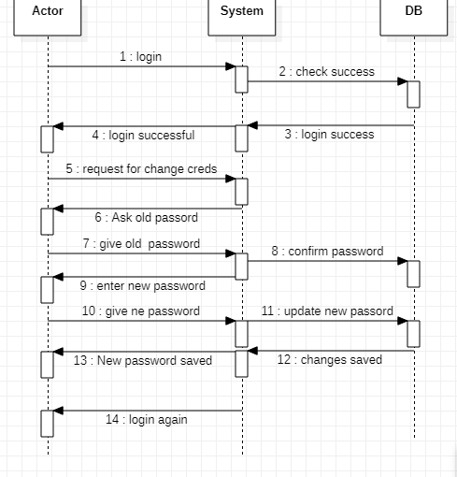

**Collect Payment:**

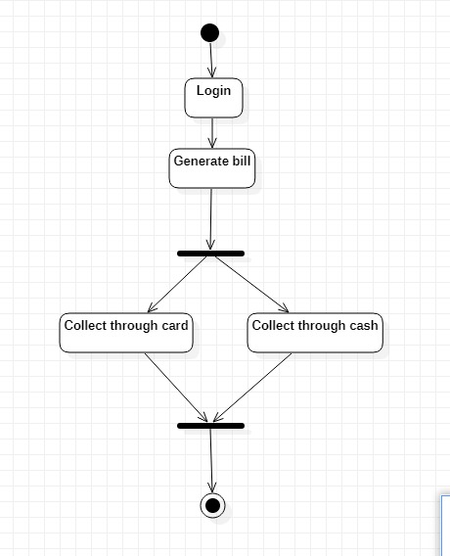

**Prescribe treatment:**

